**MOTHER MAJERI NURSERY SCHOOL**

**END OF TERM II EXAMINATION, 2024**

**CLASS : BABY CASS**

**SUBJECT: MATHS**

**My name is ________________________________stream_____**

**1. Count and copy numbers from 0-7.**

|  |  |  |  |  |  |  |  |
| --- | --- | --- | --- | --- | --- | --- | --- |
| 0 | I | 2 | 3 | 4 | 5 | 6 | 7 |
|  |  |  |  |  |  |  |  |

**2. Match the same numbers.**

7 6

8 9

3 5

l0 7

6 8

9 10

5 3

3. **Count and match the same.**

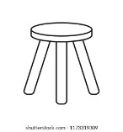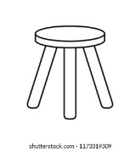















4. **Circle the correct numbers.**

I

I

I

______________________________________

2

2

2

______________________________________

3

3

3

______________________________________

4

4

4

______________________________________

5

5

5

______________________________________

6

6

6

______________________________________

7

7

7

______________________________________

8

8

8

______________________________________

5. **Count and match to numbers.**

5

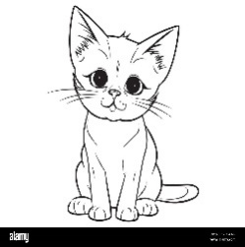

2

4

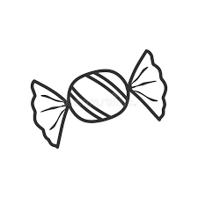

I



2

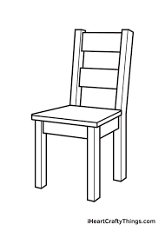3

**END**